### UE20CS301

## Database Management System

## Lab 9 – Creating Triggers

Name : Renita Kurian

SRN : PES1UG20CS331

Roll No. : 13

Question 1

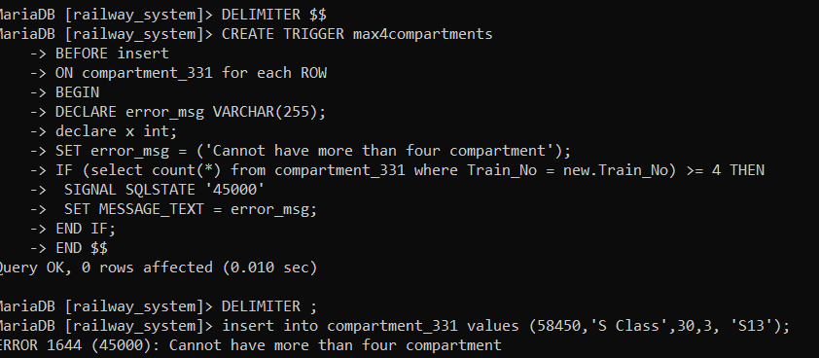



Question 2

